Experiment No.: 2
Title: Use var, let, const, and demonstrate basic features like template literals and destructuring; build a billing calculator with user input.
Software/Tools Required: HTML5, CSS3, JavaScript, VS Code , Google Chrome
Theory: JavaScript uses var, let, and const to declare variables with different scopes. The prompt() function accepts user input, while template literals simplify string formatting. Object destructuring extracts object properties into variables. These ES6 features are used to build a billing calculator that calculates the subtotal, GST (18%), and total bill, and displays a formatted receipt.

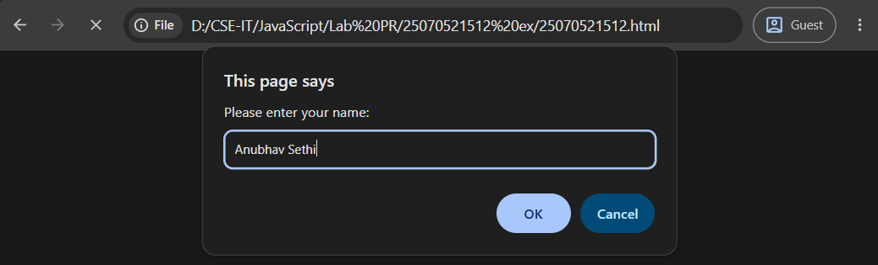
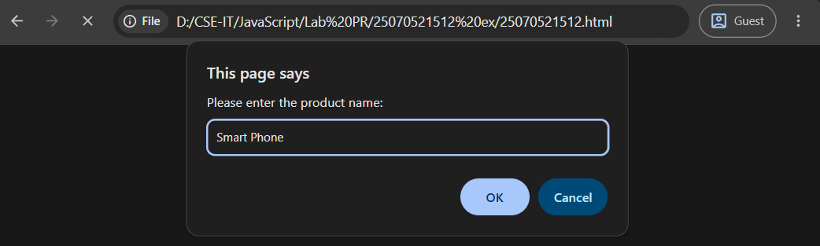
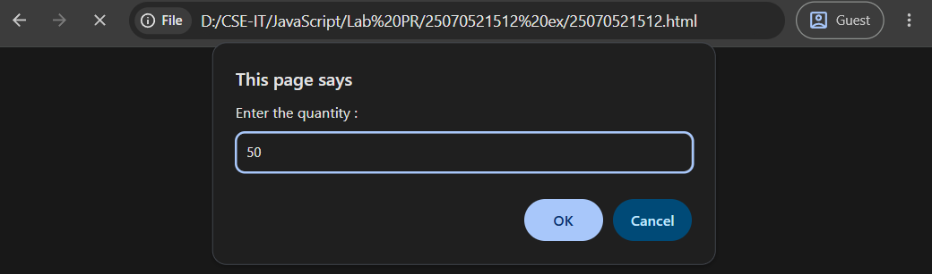
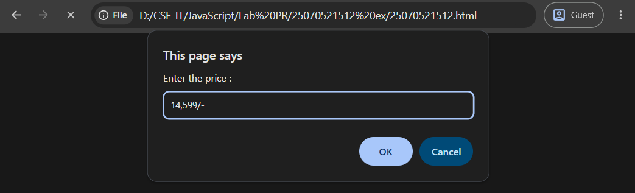
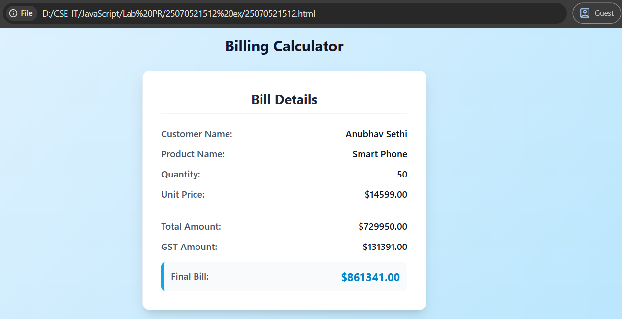

Result: A billing calculator was successfully developed using JavaScript. It accepted user input, calculated the subtotal, GST (18%), and total amount, and displayed a formatted billing receipt on the web page.
Conclusion: The experiment demonstrated the use of var, let, const, prompt(), template literals, and object destructuring to create an interactive and user-friendly billing application.

